



Maximise Data Migration

User Guide

Release 22.1

@Copyright 2022 Version 1 – All Rights Reserved

Contents

1. Overview 4

1.1. About Maximise Data Migration 4

1.1. Target Audience 4

1.2. Related Documents 4

1.3. Terminology 4

1.4. Out of Scope 5

2. Maximise Data Migration Overview 6

2.1. Architecture 6

2.2. Extract 6

2.3. Transform 6

2.4. Load 6

3. Maximise Data Migration 8

3.1. Configuration 8

3.2. Maximise Object Validation 8

3.3. Maximise Extract 10

3.4. Maximise Transform 12

3.5. Maximise Load 16

3.6. Maximise Import 17

4. Maximise Custom Extensions 19

4.1. Pre-requisites 19

4.2. How to extend and call custom code? 19

4.3. Integrate custom extensions with Maximise DM 21

5. Support For NEW ENTITIES 23

5.1. How to Integrate? 23

6. Maximise Release Process 24

6.1. Release 24

6.2. Bit Bucket 24

7. Maximise Support 25

7.1. How to raise support tickets? 25

8. APPENDIX-A 26

**Version Control**

|  |  |  |  |
| --- | --- | --- | --- |
| Date | Version | Changed By | Reason for Change |
| 29-APR-2022 | 0.1 | Pallavi Kanajar | No previous version |
| 03-MAY-2022 | 0.2 | Praveen Nair | Review |
| 18-May-2022 | 0.3 | Praveen Nair | Review |
| 06-Jun-2022 | 0.4 | Praveen Nair | Review |

**Circulation List**

|  |  |
| --- | --- |
| Name | Organisation/Title |
| Ken MacMahon | Version 1 |
| Bridget Morrissey | Version 1 |
| Praveen Nair | Version 1 |
|  |  |

# Overview

## About Maximise Data Migration

Maximise Data Migration is Version 1’s custom built toolkit to accelerate Oracle SaaS implementation. It provides a framework for extracting, transforming, and loading data from Oracle EBS and non-EBS systems into Oracle Fusion Cloud. The toolkit provides reconciliation dashboard and covers the most common data migration scenarios. Maximise Data Migration offers coverage across various applications within Oracle ERP Cloud and HCM Cloud.

Use Maximise Data Migration accelerator to quickly setup database links to extract data from a source database or use pre-defined templates for populating source data from a non-EBS database. Configure mappings in an easy-to-use template to perform simple and complex transformations. Generate load files and perform import to Fusion Cloud all through a very simple easy to use user interface.

For project teams, Maximise Data Migration accelerator also allows extension capabilities to capture customer specific requirements.

## Target Audience

This guide is intended for anyone interested in using Maximise Data Migration on Oracle cloud data migration projects.

## Related Documents

* [Maximise Data Migration Technical Checklist](https://version1.sharepoint.com/sites/ERPSolutionArchitecture/SiteAssets/SitePages/Maximise--Data-Migration/Maximise_Technical_Requirements_Checklist_v1_0.pdf?web=1)
* [Maximise Data Migration Installation Guide](https://git.version1.com/projects/VESA/repos/maximise-dm-production-release/raw/Maximise_Installation_Guide.docx?at=refs/heads/DEV)

## Terminology

Some of the terminology used in this document and across Maximise Data Migration is listed below:

|  |  |
| --- | --- |
| Key | Description |
| Maximise DM | Maximise Data Migration accelerator |
| Business Entity | Refers to a Business Application Area e.g., Finance, HCM |
| Sub Entity | Represents each level of data with Business Entity |
| Migration Set | Maximise Term used to describe the group of all sub entity data being processed in a single execution for a specific business entity. e.g., AR, AP, GL |
| File Set | Maximise DM term used to group the Source Data File from Non – EBS customers |
| Metadata | This is the driver for all the ETL processes |
| Simple Transformation | 1:1 Mapping Rule. Simple maps one source value to one target value |
| Complex Transformation | Transformation logic that includes a combination of source columns to derive a new target value |
| Phase | Data Migration Phases – Extract, Transform and Load |
| DBAAS | Database as a Service |
| STG | Staging table or act of staging data in a database table |
| XFM | Transformation activity |

## Out of Scope

* Provisioning database for Maximise DM installation. This will be the responsibility of Customer IT or Version 1 implementation teams
* All configuration items e.g., Organisation, location, job, grade, talent, position etc are the responsibility of the implementation team
* Cloud configurations cannot be implemented using Maximise DM
* Transformation and Load is out of scope for Maximise
* Customer specific customisations and mapping rules will not be covered under Maximise DM
* Data cleansing is outside the scope of Maximise Data Migration and should be performed before the Extract task

# Maximise Data Migration Overview

## Architecture

This section outlines the architecture of the Maximise Data Migration accelerator.

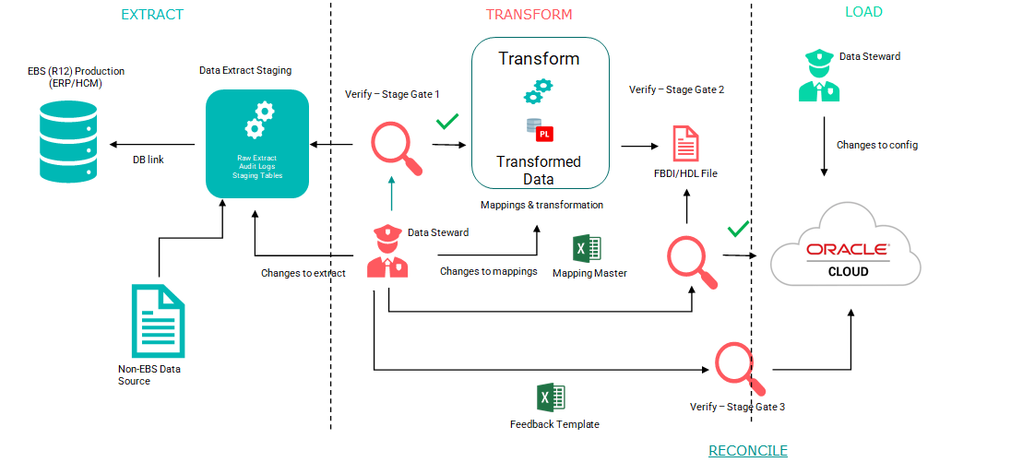

Figure 1 Maximise DM Architecture

## Extract

* A standard set of technical extract routines are deployed in a separate dedicated Oracle database (typically as DBaaS in customer cloud tenancy). These extract routines manage the extraction of data from the “Production” legacy data tables, which are then loaded to the Maximise staging (STG) tables

**NOTE:** If the source is a non-EBS Source system. A set of standardised flat files are loaded using standard Maximise extract routines.

* <<Customer>> business stewards validate the technical extracts
* The <<Customer>> business stewards provide any requisite “standard” mappings e.g., Code Combination mappings, in a pre-defined (Excel) format (“Mapping_Master Spreadsheet”). This is then loaded into the Maximise engine to drive the automatic <customer> specific mapping process, to the Transform (XFM) tables

## Transform

Data is moved, between STG and XFM, by transform routines, using <<Customer/Functional Consultant>> defined mappings, when initiated on a per entity basis. This includes technical “standard” mapping and transformation, alongside verification and validation checks to the newly configured Oracle Cloud (if any are defined in the Maximise Data Migration accelerator)

## Load

The loading of the data into the Fusion interface tables can be manual or automatic with Maximise DM. The steps in both the cases, are as follows: -

* The HDL/FBDI output is generated in CSV (“.dat”) format, by Maximise DM, which is then loaded to the Fusion (Interface Tables)
* Verify that the load interface file, for the Import process, completes successfully
* Verify that the import process completes successfully

**NOTE:** If OIC is not the Load mechanism used e.g., for SCM, these steps are performed manually after generating the “.xlsm” file.

# Maximise Data Migration

This section outlines the required configuration for Maximise Data Migration accelerator.

## Configuration

Create a standalone Database (Cloud DBAAS) with the configuration outlined below:

|  |  |
| --- | --- |
| Database Parameters | Description |
| DB Type | Standalone DB |
| Shape | VM. Standard2.2 or higher |
| OCPU Count | Minimum 2 |
| Network Bandwidth | 2 GBPS |
| Memory | 30 GB |
| Local Disk | Block Storage Only |
| Capacity type | 500GB Free Storage with On-demand configuration |
| Database System Version | 19.7.0.0.0 Standard Edition or higher |
| Character Set,  National Character Set | AL32UTF8, AL16UTF16 |
| Database Workload | OLTP |
| Pluggable Database Name | MXDM_PDB1 |

## Maximise Object Validation

The table below provides a list of table names and description for each. These tables are created as part of the Maximise Data Migration installation.

|  |  |
| --- | --- |
| Table Name | Description |
| XXMX_CORE_PARAMETERS | To Determine if the Client is EBS (DB_LINK) or Non- EBS Clients (DATA_FILE) |
| XXMX_MIGRATION_DETAILS | Batch Identifier generated by Maximise for each data set extracted |
| XXMX_MIGRATION_HEADERS | Batch Identifier generated by Maximise for each data set extracted |
| XXMX_MIGRATION_METADATA | Table holds details of Business Entity and Sub Entity. Extract packages, Staging, Transformation and External Tables. Client can enable and disable any business entity or sub entity for Extract, Transform or Load. |
| XXMX_MIGRATION_PARAMETERS | Table holds scope parameters for Extract. |
| XXMX_STG_TABLES | These are Data Dictionary Tables for Stage tables to hold details for file generation – Filename and File Delimiter etc.. |
| XXMX_STG_TABLE_COLUMNS | These are Data Dictionary Tables for Stage tables to hold details of staging columns. |
| XXMX_XFM_TABLES | These are Data Dictionary Tables for Transform tables to hold details for file generation – Filename and File Delimiter etc.. |
| XXMX_XFM_TABLE_COLUMNS | These are Data Dictionary Tables for Transform tables to hold details of staging columns. |
| XXMX_SIMPLE_TRANSFORMS | This Table holds the Rules for Simple Transformation – 1:1 Mapping |
| XXMX_MAPPING_MASTER | This table holds the Rules for Complex Transformation |
| XXMX_MODULE_MESSAGES | This table has log messages for each phase – Extract, Transform and Load |
| XXMX_FILE_LOCATIONS | This table is required to hold the File Path information to generate the csv file in Oracle Path. |
| XXMX_HDL_FILE_TEMP | HDL file for Fusion load is loaded to this table before generating the csv file. |
| XXMX_CSV_FILE_TEMP | CSV file for Fusion load is loaded to this table before generating the csv file. |
| XXMX_CUSTOM_EXTENSIONS | Customization for Business Entity can be placed in this table to plug in to Maximise. |
| XXMX_CUSTOM_SUB_EXTENSIONS | Customization for Sub Entity can be placed in this table to plug in to Maximise. |
| XXMX_UTILITIES_PKG | Maximise Core utility package |
| XXMX_DYNAMIC_SQL_PKG | Maximise Package for Transformation, Extract and Load |
| XXMX_FIN_STG_EXTRACT_PKG | Maximise Generic Package for Finance Extract and Transformation. |
| XXMX_HCM_STG_EXTRACT_PKG | Maximise Generic Package for Finance Extract and Transformation. |
| XXMX_FUSION_LOAD_GEN_PKG | Maximise Generic Package for Load file generation. |

## Maximise Extract

The section below details the pre-requisites for performing Extract and the different modes available to extract data.

### Pre-requisite

* Make sure database link is operating

***Note****: This is mandatory for EBS customers only*

* All Maximise database objects are in Valid Status
* All Staging tables, Transformation Tables are installed. Details of objects can be obtained from the **XXMX_MIGRATION_METADATA** table
* All configuration objects, covered under section 3.2 are installed and valid
* The Maximise tables below should be populated for the relevant business entities, for Extract
  + XXMX_MIGRATION_METADATA
  + XXMX_MIGRATION_PARAMETERS
  + XXMX_CORE_PARAMETERS
  + XXMX_LOOKUP_VALUES
  + XXMX_STG_TABLES
  + XXMX_XFM_TABLES
* **For non-EBS customers**, data file should be placed in the Oracle path defined in the directory SOURCE_DATAFILE. The path for this directory should be maintained in the XXMX_MIGRATION_PARAMETERS table. By default, the Maximise team will configure the path as ‘/tmp’ for the customer. The implementation team can change it as per their requirement

### Extract Mode – PLSQL

The sections below highlight the steps required to extract data using SQL Developer for both Finance and HCM.

#### Finance and SCM

* Populate the following parameters in the XXMX_MIGRATION_PARAMETERS table and enable or disable, as required.
  + Operating Unit (PARAMETER_CODE=’ORGANIZATION_NAME’)
  + Business group (PARAMETER_CODE=’BUSINESS_GROUP_NAME’)
  + GL Ledger Names (PARAMETER_CODE=’LEDGER_NAME’)
* List of Maximise provided parameters are provided under the Appendix-A section for reference. Implementation teams can enable them or disable them as required
* In SQL Developer, change buffer size to 20000.



***Note:*** *FILE_SET_ID is mandatory for non-EBS customers only*

#### HCM

* Populate the following parameters in the XXMX_MIGRATION_PARAMETERS table and enable or disable, as required.
  + Person Types (PARAMETER_CODE=PERSON_TYPE’)
  + Business Groups (PARAMETER_CODE=’BUSINESS_GROUP_NAME’)
  + Payroll (PARAMETER_CODE=’PAYROLL_NAME’)
  + Migration Dates (PARAMETER_CODE=’MIGRATION_DATE_FROM’ and ‘MIGRATION_DATE_TO’)
* In SQL Developer, change buffer size to 20000



***Note:*** *FILE_SET_ID is mandatory for non-EBS customers only*

### Extract Mode – VBCS

The sections below highlight the steps required to extract data using the Maximise DM user interface.

#### Generate STG Data

* Select the **Application Suite** and **Business Entity** to extract the data from the source EBS tables

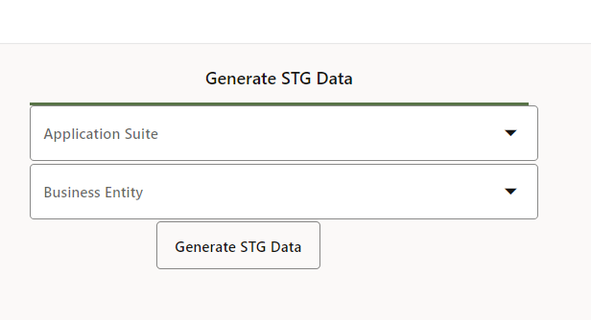

Figure 2 Maximise UI-Generate STG Data

* For non-EBS customers, new parameter will be visible to pass Mandatory file_set_id from Source Data File
* The VBCS API routines in turn calls OIC workflow processes to launch the PLSQL Extract
* The result of the processing can be reviewed by querying the staging tables



#### Upload STG Data

Select the Application Suite, Business Entity, Iteration and Migration Set ID to generate the extracted data file. The new file will be placed in the pre-configured FTP path and can be used for reconciliation purposes.

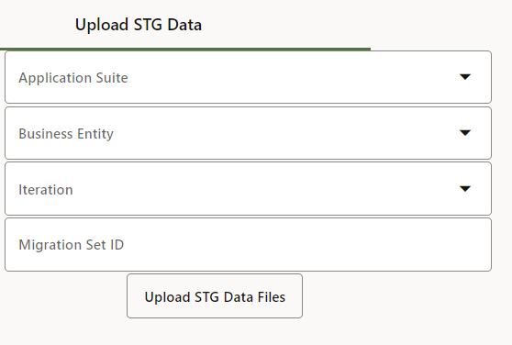

Figure 3 Maximise UI-Upload STG Data

## Maximise Transform

### Pre-requisite

* The Maximise tables below should be populated.
  + XXMX_SIMPLE TRANSFORMS
  + XXMX_MAPPING MASTER
  + XXMX_STG_TABLE_COLUMNS
  + XXMX_XFM_TABLE_COLUMNS

Download the mapping master spreadsheet (use link below) to capture all simple and complex transformations. This is required for Maximise DM to perform transformations on extracted data.

[​xlsm icon MaximiseMappingMasterHCM.xlsm](https://version1.sharepoint.com/sites/ERPSolutionArchitecture/Shared%20Documents/Maximise/MaximiseMappingMasterHCM.xlsm?web=1)

* Merge all the mapping to Master Tab using the macro “**MERGE_SHEETS**”
* **Navigation:** *View > Macros > View Macros > Select Merge sheets > Run*

Figure 4 Maximise Mapping Spreadsheet

* Create a new workbook for the **Master** tab. Save the new workbook as a csv file
* Right-click on the **Master** tab and select ***Move or Copy…***

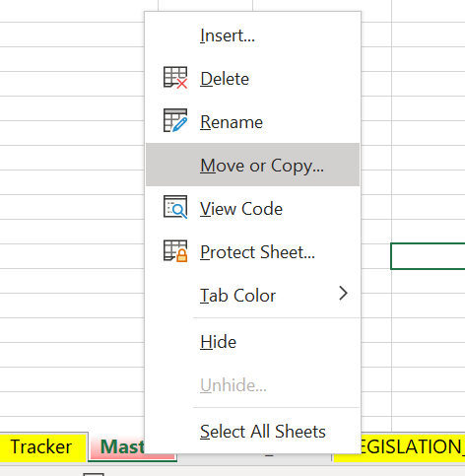

Figure 5 Maximise Mapping-New Worksheet

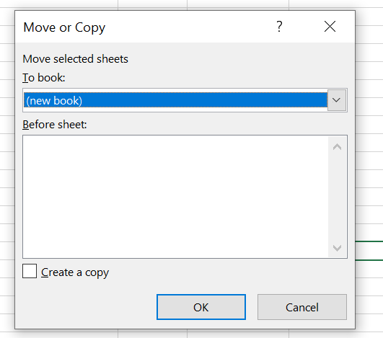

Figure 6 Maximise Mapping-Copy

* Click **OK**
* Save the document as a **CSV** file

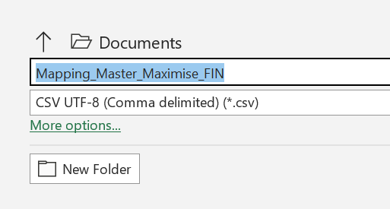

Figure 7 Maximise Mapping-New File

* Generated **CSV** should be placed in the pre-defined FTP server path

***UserName :*** *<OIC Username>*

***Password:*** *<OIC Password>*

***File Path:*** */home/user/<OIC Username>/client_csv*

* Generated **CSV** file can be loaded to OIC Integration - to map the data in the Maximise tables **XXMX_SIMPLE_TRANSFORMS** and **XXMX_MAPPING_MASTER**

OIC Integration Name is “***INTDM999005 Data Migration Mapping Process***”

### Transform from PLSQL

* After completing the mapping, both the Simple and Complex Transformation data are moved to the respective Maximise tables
* Get Migration_Set_ID from Staging tables using the following call:



***Note:*** *FILE_SET_ID is mandatory for non-EBS customers only*

* Transformed data will be inserted into Maximise XFM Tables.

### Transform from VBCS

#### Generate XFM Data

* Select the **Application Suite**, **Business Entity** to Transform the data from Staging tables
* Staging table should have only one **Migration_Set_ID**

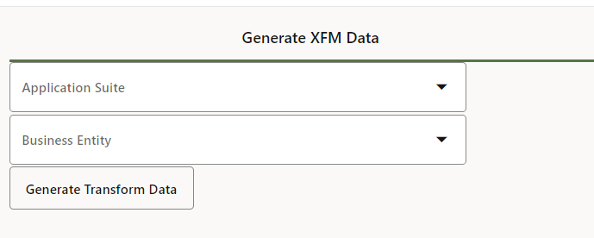

Figure 8 Maximise Transform-Generate XFM Data

* For Non-EBS customers new parameter will be visible to pass mandatory File_Set_Id from Source Data File.
* The VBCS API routines in turn calls OIC workflow processes to launch the PLSQL Transformation
* Once the Transformation process is successful (from PLSQL or VBCS), check the respective transformation tables to verify if data is populated. The list of transformation tables can be obtained from the **XXMX_MIGRATION_METADATA** table



#### Upload XFM Data

Select the Application Suite, Business Entity, Iteration and Migration Set ID to generate the transformed data file. This file is then placed in the pre-configured OIC FTP Path location, for reconciliation purposes.

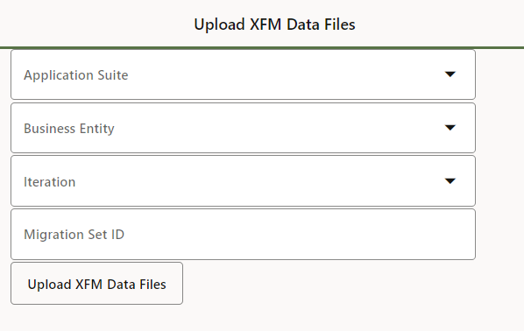

Figure 9 Maximise Transform-Upload XFM Data File

## Maximise Load

### Pre-requisite

* File path is setup in the **XXMX_FILE_LOCATIONS** table
* Populate the **XXMX_XFM_TABLES, XXMX_XFM_TABLE_COLUMNS** for columns *fusion_template_field_name, field_delimiter, mandatory* and *Include_in_outbound_file*

***Note****: All these configurations are part of Maximise Installation and are provided here for information only*

* Fusion import parameters must be setup in the table **XXMX_DM_ESS_JOB_DEFINITIONS**
* Table **XXMX_DM_ASSET_BOOKS_IN_SCOPE** must be populated for Fixed Assets Migration.
* Table **XXMX_FUSION_BUSINESS_UNITS** must be populated for all Finance migration.
* Table **XXMX_DM_FUSION_DAS** must be populated for Journal Migration.

### Load from PLSQL

Execute the below package in SQL Developer to generate the load file



* HCM Data will be generated in the table **XXMX_HDL_FILE_TEMP**
* Finance Data will be generated in the table **XXMX_CSV_FILE_TEMP**

### Load from VBCS

#### Generate Load File

* To generate the Load File, populate the parameters for Application Suite, Business Entity, Sub Entity, and Iteration

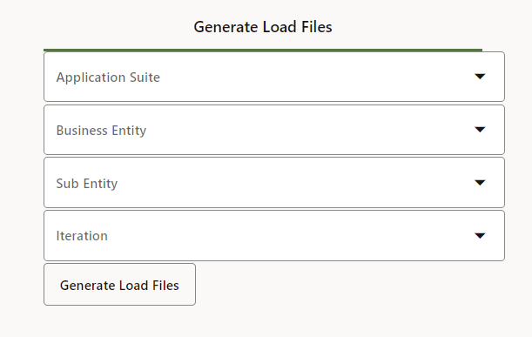

Figure 10 Maximise Load-Generate Load Files

* HCM data will be created in **XXMX_HDL_FILE_TEMP** and finance data will be created in the **XXMX_CSV_FILE_TEMP** table
* .**CSV** or .**DAT** file is created in the pre-defined FTP location

#### Load File to Fusion Interface

* This step is applicable for Finance only. Populate the parameters - **Application Suite, Business Entity, Sub Entity,** and **Iteration**.

***Note:*** *This step is not applicable for HCM (Fusion HDL for HCM processes both load and import)*

* This step will load the Interface tables in Fusion for Finance , SCM and PPM.

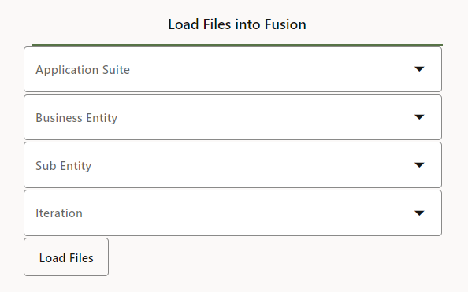

Figure 11 Maximise Load-Load Files to Fusion

## Maximise Import

### Pre-requisite

* Table **XXMX_DM_ESS_JOB_DEFINITIONS** must be setup for capturing import parameters
* Fusion connection details must be working, and Fusion user must have the required data access
* Import functionality is automated only in VBCS

### Import from VBCS

Import works for both Finance and HCM. The data is imported to Fusion Base Tables from this screen.

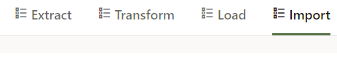

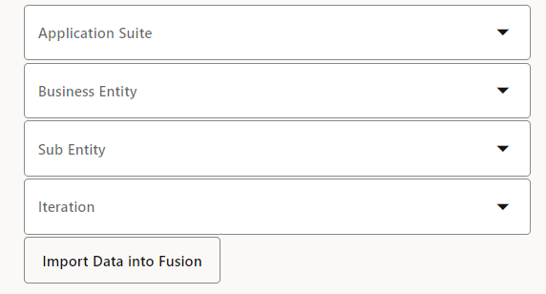

Figure 12 Maximise Import-Import to Fusion

# Maximise Custom Extensions

Custom extensions in Maximise Data Migration, provide the Version 1 implementation team functionality to extend Maximise Data Migration accelerator to capture customer specific requirements e.g., for additional validation.

Implementation/delivery teams can add custom rules to existing Extract and Transform routines.

## Pre-requisites

* The custom code units should be part of a package definition. The custom code for extension should be added in a new package maintained by the delivery/implementation team
* The procedure should follow a specific set of parameters, as per Maximise definition to integrate with Maximise
* **XXMX_CUSTOM_EXTENSIONS** and **XXMX_CUSTOM_SUB_EXTENSIONS** should be populated for business entity or sub entity custom logic extension (see section 4.4)

## How to extend and call custom code?

Create a bespoke PL/SQL code unit to extend the existing extract and transform code

### Sample Extension - Extract

* Create the custom package in the **XXMX_CORE** schema for handling customer specific logic for a specific business entity



Figure 13 Extract extension sample for a business Entity

* Create the custom package in **XXMX_CORE** schema for handling customer specific logic for a specific business sub-entity



Figure 14 Extract extension sample for a business Sub-Entity

### Sample Extension - Transform

If complex transformation rules are required, define PL/SQL code units with the rules and integrate it with Maximise

**Note:** *We recommend keeping the code units grouped in a package for ease of maintenance*

* Create the custom package in the **XXMX_CORE** schema for handling customer specific logic for a specific business entity



Figure 15 Transform sample for a business entity

* Create the custom package in **XXMX_CORE** schema for handling customer specific logic for a specific business sub-entity



Figure 16 Transform sample for a business sub-entity

## Integrate custom extensions with Maximise DM

### Extract

To integrate business entity extensions with Maximise, create an entry in the **XXMX_CUSTOM_EXTENSIONS** table as follows:



To integrate business sub-entity extensions with Maximise, create an entry in the **XXMX_CUSTOM_EXTENSIONS** table as follows:



### Transform

To integrate business entity extension with Maximise, create an entry in the table **XXMX_CUSTOM_EXTENSIONS**



To integrate business sub-entity extension with Maximise, create an entry in the table **XXMX_CUSTOM_EXTENSIONS**



# Support For NEW ENTITIES

This section details, steps to add new business entities in Maximise which is not part of the standard Maximise DM accelerator.

## How to Integrate?

* Delivery teams can create the extract package and required staging and transformation tables
* The staging and transformation tables should have the columns as per the FBDI/HDL template for the business entity or sub-entity. Additional columns can also be added if required by the business
* Extract package should be in the format of the package “**xxmx_fin_<sub_entity>_ext_pkg.sql**” provided in the accelerator for FIN and SCM application
* Extract package should be in the format of the package “**xxmx_hcm_<sub_entity>_ext_pkg.sql**” provided in the accelerator for HCM application
* When the tables and packages are ready, create an entry in the table **xxmx_migration_metadata** for the extract as shown below:



**Note: You can also reach out to Maximise to guide you with this process**

# Maximise Release Process

## Release

All updates for Maximise DM will be released quarterly. Releases will be following the Year.Quarter nomenclature. For e.g., release in quarter year 2022, quarter 3 will be 22.3.

## Bit Bucket

All new releases for Maximise DM will be available under the named release branch in Bitbucket. For e.g., the latest release at the time of writing this document is Release 22.1 is available under it’s own branch (see below)

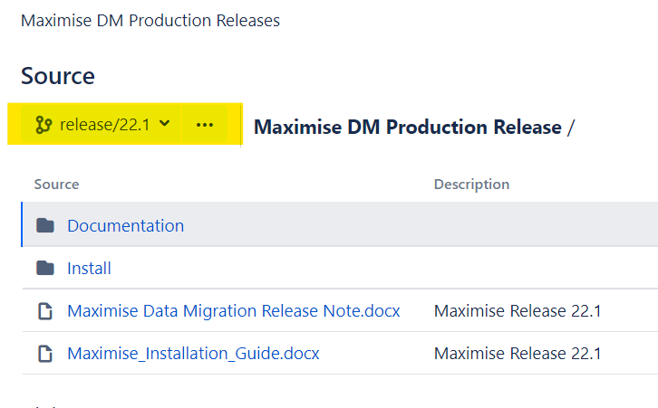

The URL to download the latest version of Maximise DM is :

<https://git.version1.com/projects/VESA/repos/maximise-dm-production-release>

***Note:*** *Select the correct branch from the drop-down list to download the latest version of the installer*

Refer to the [Maximise Installation Guide](https://git.version1.com/projects/VESA/repos/maximise-dm-production-release/browse/Maximise_Installation_Guide.docx) for installation instructions

# Maximise Support

## How to raise support tickets?

To log Maximise DM related queries, issues, and enhancement requests, log a ticket with the Maximise team using the link - [Maximise DM Raise Support Ticket](https://dev.azure.com/Version1InnovationLabs/Maximise%20Data%20Migration/_workitems/create/Issue)

***Note:*** *For those who are unable to log a ticket due to access issues, raise a request with* [*simon.wraight@version1.com*](mailto:simon.wraight@version1.com)

# APPENDIX-A

List of Parameters used in Maximise Extract

|  |  |  |  |  |  |  |  |
| --- | --- | --- | --- | --- | --- | --- | --- |
| APPLICATION  SUITE | APPLICATION | BUSINESSENTITY | SUB_ENTITY | PARAMETER_CODE | PARAMETER_VALUE | ENABLED  FLAG | DATA_SOURCE |
| FIN | ALL | ALL | ALL | EXTERNAL_DIR | SOURCE_DATAFILE | Y | XXMX |
| FIN | ALL | ALL | ALL | FTP_ENABLED | Y | Y | XXMX |
| FIN | ALL | ALL | ALL | ORGANIZATION_NAME | <Client Organization_name> | Y | SOURCE_DB |
| FIN | AP | INVOICES | INVOICE_LINES | DEFAULT_DIST_CODE_CONCATENATED | YY-YYYYY-YYYYY-YYYYY-00000000 | Y | XXMX |
| FIN | AP | INVOICES | INVOICE_HEADERS | DEFAULT_IMPORT_SOURCE | Data Migration | Y | XXMX |
| FIN | AP | INVOICES | INVOICE_HEADERS | DEFAULT_PAY_CODE_CONCATENATED | XX-XXXXX-XXXXX-XXXXX-00000000 | Y | XXMX |
| FIN | AP | INVOICES | INVOICE_HEADERS | DEFAULT_PAY_CODE_CONCATENATED | XX-XXXXX-XXXXX-XXXXX-00000000 | Y | XXMX |
| FIN | AP | INVOICES | ALL | INVOICE_TYPE | STANDARD | Y | SOURCE_DB |
| FIN | AP | INVOICES | ALL | MONTHS_TO_MIGRATE | 18 | Y | XXMX |
| FIN | AP | SUPPLIERS | ALL | MONTHS_TO_MIGRATE | 96 | Y | XXMX |
| FIN | AP | SUPPLIERS | SUPPLIER_PMT_INSTRS | ORDER_OF_PREFERENCE_LIMIT | 1 | Y | XXMX |
| FIN | AP | SUPPLIERS | ALL | VENDOR_TYPE | VENDOR | N | SOURCE_DB |
| FIN | AP | SUPPLIERS | ALL | VENDOR_TYPE | #NULL | N | XXMX |
| FIN | AR | CUSTOMERS | ALL | INCLUDE_INACTIVE_ACCOUNTS | Y | Y | XXMX |
| FIN | AR | CUSTOMERS | ALL | INCLUDE_INACTIVE_SITES | Y | Y | XXMX |
| FIN | AR | CUSTOMERS | ALL | MONTHS_TO_MIGRATE | 18 | Y | XXMX |
| FIN | AR | CUSTOMERS | ALL | NO_ACTIVITY_CUSTOMER_MONTHS | 2 | Y | XXMX |
| FIN | AR | TRANSACTIONS | ALL | AR_TRX_SOURCE_ID | 300000012242895 | Y | XXMX |
| FIN | AR | TRANSACTIONS | ALL | INCLUDE_CREDIT_MEMOS | Y | Y | XXMX |
| FIN | AR | TRANSACTIONS | ALL | INCLUDE_DEBIT_MEMOS | Y | Y | XXMX |
| FIN | FA | ALL | ALL | BOOK_TYPE_CODE | OPS CORP | Y | SOURCE_DB |
| FIN | FA | ALL | ALL | CUT_OFF_DATE | 31-AUG-2021 | Y | XXMX |
| FIN | GL | ALL | ALL | LEDGER_NAME | ABC PRIMARY LEDGER | N | SOURCE_DB |
| FIN | GL | BALANCES | ALL | EXTRACT_YEAR | 2009 | Y | XXMX |
| FIN | GL | BALANCES | ALL | EXTRACT_YEAR | 2010 | Y | XXMX |
| FIN | GL | BALANCES | ALL | EXTRACT_YEAR | 2014 | Y | XXMX |
| FIN | GL | BALANCES | ALL | EXTRACT_YEAR | 2015 | Y | XXMX |
| FIN | GL | BALANCES | ALL | PERIOD_NAME | APR-15 | Y | SOURCE_DB |
| FIN | GL | BALANCES | ALL | PERIOD_NAME | APR-20 | Y | SOURCE_DB |
| FIN | GL | BALANCES | ALL | PERIOD_NAME | JUN-09 | Y | SOURCE_DB |
| FIN | GL | GENERAL_LEDGER | ALL | JE_CATEGORY | AP Subledger Entries | Y | NULL |
| FIN | GL | GENERAL_LEDGER | ALL | JE_SOURCE | Payables | Y | NULL |
| FIN | GL | GENERAL_LEDGER | ALL | PERIOD_NAME | 11-09 | Y | NULL |
| FIN | GL | GENERAL_LEDGER | ALL | STATUS | P | Y | NULL |
| FIN | PPM | ALL | ALL | EXTRACT_END_DATE | 31-DEC-1997 | Y | XXMX |
| FIN | PPM | ALL | ALL | EXTRACT_START_DATE | 01-JAN-1997 | Y | XXMX |
| FIN | PPM | ALL | ALL | GL_PERIOD_NAME | MAR-97 | Y | XXMX |
| FIN | PPM | PRJ_COST | ALL | COST_EXT_TYPE | DETAIL | Y | XXMX |
| FIN | PPM | PRJ_COST | EXPENSE_COST | EXP_SYSTEM_LINK_TYPE | ER | Y | SOURCE_DB |
| FIN | PPM | PRJ_COST | SUPPLIER_COST | EXP_SYSTEM_LINK_TYPE | VI | Y | SOURCE_DB |
| FIN | PPM | PRJ_COST | MISC_COSTS | EXP_SYSTEM_LINK_TYPE | PJ | Y | SOURCE_DB |
| FIN | PPM | PRJ_COST | LABOUR_COST | EXP_SYSTEM_LINK_TYPE | OT | Y | SOURCE_DB |
| FIN | PPM | PRJ_COST | LABOUR_COST | EXP_SYSTEM_LINK_TYPE | ST | Y | SOURCE_DB |
| FIN | PPM | PRJ_COST | NON_LBR_COST | EXP_SYSTEM_LINK_TYPE | INV | Y | SOURCE_DB |
| FIN | PPM | PRJ_COST | NON_LBR_COST | EXP_SYSTEM_LINK_TYPE | WIP | Y | SOURCE_DB |
| FIN | PPM | PRJ_COST | NON_LBR_COST | EXP_SYSTEM_LINK_TYPE | USG | Y | SOURCE_DB |
| FIN | PPM | PRJ_COST | NON_LBR_COST | EXP_SYSTEM_LINK_TYPE | BTC | Y | SOURCE_DB |
| FIN | PPM | PROJECTS | ALL | PROJECT_STATUS_CODE | 1105 | Y | SOURCE_DB |
| FIN | PPM | PROJECTS | ALL | PROJECT_STATUS_CODE | 1254 | Y | SOURCE_DB |
| FIN | PPM | PROJECTS | ALL | PROJECT_STATUS_CODE | SUBMITTED | Y | SOURCE_DB |
| FIN | PPM | PROJECTS | ALL | PROJECT_STATUS_CODE | PURGED | Y | SOURCE_DB |
| FIN | PPM | PROJECTS | ALL | PROJECT_STATUS_CODE | APPROVED | Y | SOURCE_DB |
| FIN | PPM | PROJECTS | ALL | PROJECT_STATUS_CODE | CLOSED | Y | SOURCE_DB |
| FIN | PPM | PROJECTS | ALL | PROJECT_STATUS_CODE | 1003 | Y | SOURCE_DB |
| FIN | PPM | PROJECTS | ALL | PROJECT_STATUS_CODE | ACTIVE | Y | SOURCE_DB |
| FIN | PPM | PROJECTS | ALL | PROJECT_STATUS_CODE | UNAPPROVED | Y | SOURCE_DB |
| FIN | PPM | PROJECTS | ALL | PROJECT_TYPE | Construction-Bill | Y | SOURCE_DB |
| HCM | ALL | ALL | ALL | FTP_ENABLED | Y | Y | XXMX |
| HCM | ALL | ALL | ALL | SOURCESYSTEMOWNER | EBS | Y | XXMX |
| HCM | HR | ALL | ALL | ASSIGNMENT_DFF | I | Y | XXMX |
| HCM | HR | ALL | ALL | BUSINESS_GROUP_NAME | <Client Business Group> | N | SOURCE_DB |
| HCM | HR | ALL | ALL | PEOPLE_GROUP | SEGMENT1-SEGMENT3 | Y | XXMX |
| HCM | HR | HCMEMPLOYEE | ALL | MIGRATE_DATE_FROM | 1992-01-01 | Y | XXMX |
| HCM | HR | HCMEMPLOYEE | ALL | MIGRATE_DATE_TO | 2019-01-01 | Y | XXMX |
| HCM | HR | HCMEMPLOYEE | ALL | PERSON_TYPE | EX_EMPLOYEE | N | SOURCE_DB |
| HCM | HR | HCMEMPLOYEE | ALL | PERSON_TYPE | EMPLOYEE | Y | SOURCE_DB |
| HCM | HR | HCMEMPLOYEE | ALL | PERSON_TYPE | CONTINGENT WORKER | Y | SOURCE_DB |
| HCM | HR | HCMEMPLOYEE | ALL | PREV_TAX_YEAR_DATE | 2019-01-01 | Y | XXMX |
| HCM | IREC | ALL | ALL | MIGRATE_DATE_FROM | 1992-01-01 | Y | XXMX |
| HCM | IREC | ALL | ALL | MIGRATE_DATE_TO | 2019-01-01 | Y | XXMX |
| HCM | IREC | CANDIDATE | ALL | PERSON_TYPE | EXTERNAL | Y | SOURCE_DB |
| HCM | IREC | CANDIDATE | ALL | PERSON_TYPE | APPLICANT | Y | SOURCE_DB |
| HCM | IREC | JOB_REFERRAL | ALL | MIGRATE_DATE_FROM | 1992-01-01 | Y | XXMX |
| HCM | IREC | JOB_REFERRAL | ALL | MIGRATE_DATE_TO | 2019-01-01 | Y | XXMX |
| HCM | IREC | JR_HIRING_TEAM | ALL | MIGRATE_DATE_FROM | 1992-01-01 | Y | XXMX |
| HCM | IREC | JR_HIRING_TEAM | ALL | MIGRATE_DATE_TO | 2019-01-01 | Y | XXMX |
| HCM | PAY | PAYROLL | ALL | PAYROLL_NAME | Vision Weekly | Y | SOURCE_DB |
| HCM | PAY | PAYROLL | ALL | SCOPE_ELEMENT_NAME | Student Loan | Y | XXMX |
| HCM | PAY | PAYROLL | ALL | SCOPE_ELEMENT_NAME | NI | Y | XXMX |
| HCM | PAY | PAYROLL | ALL | SCOPE_ELEMENT_NAME | PAYE Details | Y | XXMX |
| SCM | PO | PURCHASE_ORDERS | ALL | INCLUDE_FULLY_RECEIPTED_POS | N | Y | XXMX |
| SCM | PO | PURCHASE_ORDERS | ALL | MONTHS_TO_MIGRATE | 18 | Y | XXMX |
| SCM | PO | PURCHASE_ORDERS | ALL | ORGANIZATION_NAME | <Client Organization_name> | Y | SOURCE_DB |
| SCM | PO | PURCHASE_ORDERS | ALL | PO_TYPE | STANDARD | Y | SOURCE_DB |
| SCM | PO | PURCHASE_ORDERS | ALL | PO_TYPE | BLANKET | Y | SOURCE_DB |
| XXMX | GL | UTILITIES | DEFAULT_ACCOUNT_TRANSFORMS | PLACEBO_SEGMENT_VALUE | # | Y | XXMX |
| XXMX | GL | UTILITIES | DEFAULT_ACCOUNT_TRANSFORMS | USE_PLACEBO_SEGMENT_VALUE | Y | Y | XXMX |